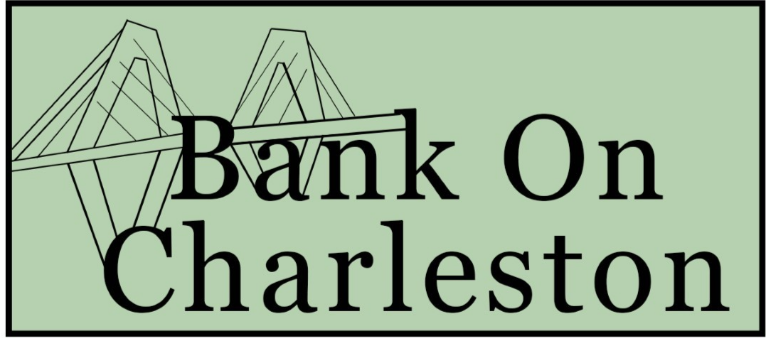
Financial Empowerment Workshops Information
The City of Charleston is offering youth the opportunity to gain skills and knowledge regarding personal finance through virtual workshops this summer!
We invite any high school or college age youth to participate in the Bank On Charleston Financial Empowerment Initiative. Topics are listed in detail below and the goal is to help you understand how to set up and follow a budget, establish a savings plan, and establish good credit.
There will also be an incentive program that will allow you the chance to win prizes for practicing your financial skills. Our goal is to give you a solid financial base and encourage you to establish good money habits. The workshops will build on the topics from the weeks before so that by the end of the summer you will have comprehensive knowledge of personal finance.
Schedule and topics:
All workshops will be held virtually via Zoom from 9:30 a.m. - 11:00 a.m. on Fridays. Each week we will cover a personal finance topic and have a guest speaker. If you are not able to attend the live session, a recording will be provided to you with a quiz or worksheet to turn in to show your learning.
- Week 1: June 17 Budgeting, saving, and the importance of a bank account
- Week 2: June 24 Smart spending and realistic goals
- Week 3: July 8 Establishing credit and managing debt
- Week 4: July 15 Long term financial goals: college, investing, big ticket items

Incentives of the program
Along with learning new skills there are incentives for participating! The more you participate and practice financial skills the better your chances of winning one of the raffle prizes. We will raffle off prizes among those who complete the tasks each week. The prizes will be gift cards to local venues and/or restaurants. Listed below are specifics of participation and requirements.
- Workshop 1
  - Complete Week 1 budget sheet/ track spending
  - Submit a picture/copy to Mindy
    - sturmm@charleston-sc.gov; 843-860-2233
- Workshop 2
  - Complete Week 2 budget sheets/ track spending
  - Complete realistic savings goals worksheet
  - Submit a picture/copy to Mindy
    - sturmm@charleston-sc.gov; 843-860-2233
- Workshop 3
  - Complete Week 3 budget sheets/ track spending
  - Show savings goal progress
  - Submit a picture/copy to Mindy
    - sturmm@charleston-sc.gov; 843-860-2233

- Workshop 4
  - Complete Week 4 budget sheets/ track spending
  - Show savings goal progress
  - Submit a picture/copy to Mindy
    - sturmm@charleston-sc.gov; 843-860-2233

The worksheets will be Due by Monday, at 5:00 pm.
The Zoom Link will be sent each week by Thursday. To register, email Mindy Sturm at sturmm@charleston-sc.gov or call 843-965 -4190.
If you know of anyone else that would be interested in participating, please have them email Mindy as well- this is open to anyone!
Happy Saving!

