  - WAI / GIAD planning meeting  Getting Ready to host the best GIAD ever in SC!!!!!!  Where: Signature Aviation CHS Date: Thurs. 7/23 from 4-6pm. inventory on hand for GIAD report out, brainstorming ideas, activities, fundraising, sponsorship. BRING IT!!!!  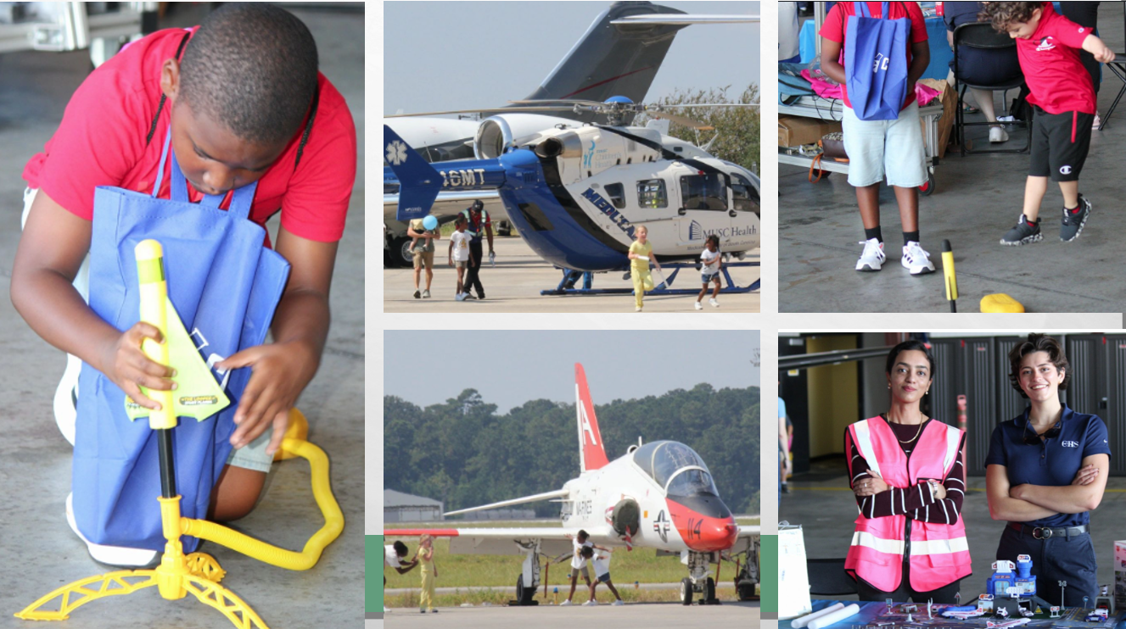
  Planning out 2026
  ____
  You don’t want to miss -we are gearing up for GIAD, the best event of the year!
  ____
  WE decide the outcome!
  ____
  WE inspire the next generation!
  ____
  You do not want to miss this!
  wai MEETING
  Locations: Signature CHS
  5875 S Aviation Ave,
  North Charleston SC
  843-991-9396
  TUES 7/23 FROM 4-6PM

